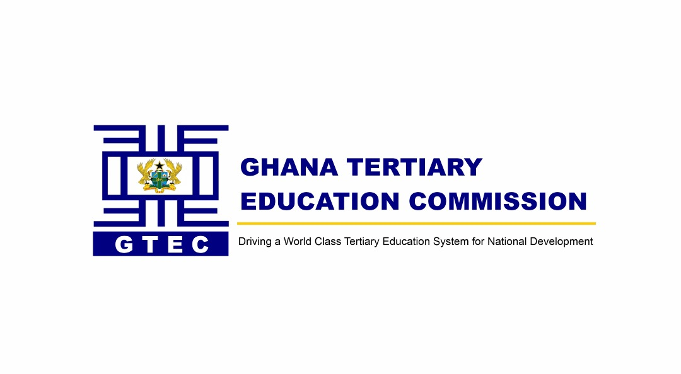

**IMPORTANT NOTICE (UNACCREDITED STUDY CENTRES)**

The Ghana Tertiary Education Commission (GTEC) announces for the information of the public, especially parents/guardians and prospective students, that the **study centres** used by the **University of Cape Coast (UCC)**, **University for Development Studies (UDS)**, and **University of Education, Winneba (UEW)** to run academic programmes are not accredited.

**As a result, applicants who pursue programmes at these CENTRES do so at their own risk.**

The unaccredited **study centres** are shown below:

1. **UNIVERSITY OF CAPE COAST (UCC)**

|  |  |
| --- | --- |
| **NO.** | **Unaccredited study centres** |
|  | Dreamfield International School, Sunyani |
|  | Fountainhead University College, Tema |
|  | Great Victory Academy, Bolgatanga |
|  | Holy Child College of Education, Takoradi |
|  | Holy Trinity Lutheran School, Kumasi |
|  | King Jesus School Annex, Koforidua |
|  | Kumasi Technical Institute, Kumasi |
|  | Mawuli School, Ho |
|  | Tamale College of Education, Tamale |
|  | Wa Senior High School, Wa |
|  | Zebilla Senior High School, Zebilla |
|  | Zenith College, Accra |
|  | Abetifi College of Education, Abetifi |
|  | Accra Senior High School, Accra |
|  | Ada College of Education, Ada |
|  | Ada Senior High School, Ada |
|  | Agona Swedru School of Business, Agona Swedru |
|  | Akatsi College of Education, Akatsi |
|  | Akwamuman Senior High School, Akwamu |
|  | Apam Senior High School, Apam |
|  | Atebubu Senior High School, Atebubu |
|  | Attafuah Sec./Tech. Sch. Akim Oda |
|  | Begoro Presby Senior High School, Berogo |
|  | Boa Amponsem Senior High School, Dunkwa –on-Offin |
|  | Bolga Girls Senior High School, Bolgatanga |
|  | Breman Asikuma Senior High School, Breman |
|  | Damongo Senior High School, Damongo |
|  | Dormaa Ahenkro Senior High School, Dorma Ahenkro |
|  | Drobo Senior High Senior, Drobo |
|  | Dwamena Akenten Senior High Senior, Offinso |
|  | Enchi Senior High School, Enchi |
|  | Fiaseman Senor High School, Tarkwa |
|  | Frafraha Senior High School, Frafraha |
|  | Gambaga College of Education, Gambaga |
|  | Ghana Senior High School, Koforidua |
|  | Hwidiem Senior High School, Hwidiem |
|  | Ignis School, Nsawam |
|  | Jasikan College of Education, Jasikan |
|  | Keta Business School, Keta |
|  | Kintampo Senior High School, Kintampo |
|  | Lashibi Community Senior High School, Lashibi |
|  | Konongo Odumase Senior High School, Konongo |
|  | Kumasi Senior High Technical School, Patasi |
|  | Kumasi Technical Institute, Kumasi |
|  | Lawra Senior High School, Lawra |
|  | Lutheran School, Kanda |
|  | Mansoman Senior High School, Mansoman Atwere |
|  | Chemu Senior High School, Chemu |
|  | Mary Star of the Sea, Kasoa |
|  | Mmofraturo School, Kumasi |
|  | Nandom Senior High School, Nandom |
|  | Ngleshie Amanfrom, Kasoa |
|  | Nkoranman Senior High School, Seikwa |
|  | Nkoranza Secondary Technical, Nkoranza |
|  | River View Nursing and Allied Health College, Accra |
|  | Notre Dame Minor Seminary Senior High School, Navrongo |
|  | Nsawam Prisons |
|  | Nsein Senior High School, Nsein |
|  | Obiri Yeboah Senio High School, Foso |
|  | Obuasi Secondary Technical School, Obuasi |
|  | Odorgonno Secondary School, Odorgonno |
|  | Oyoko Methodist Senior High School, Oyoko-Koforidua |
|  | Salaga Senior High School, Salaga |
|  | Sefwi Debiso Senior High School, Sefwi Debiso |
|  | Sefwi Juaboso Senior High School, Sefwi Juaboso |
|  | Wiawso College of Education, Wiawso |
|  | Serwaa Nyarko Senior High School, Kumasi |
|  | SIMMS College, Kumasi |
|  | Sokode Senior High School, Ho |
|  | Yilo Krobo SEC. Tech. school, Yilo Krobo |
|  | St. John’s Senior High School, Sekondi |
|  | St. Margaret Mary Senior High School, Accra |
|  | Sunyani Technical University, Sunyani |
|  | Sunyani Senior High School, Sunyani |
|  | Swedru Senior High School, Agona Swedru |
|  | T.I Ahmadiya Senior High School, Kumasi |
|  | Takoradi Senior High School, Takoradi |
|  | Tamale College of Education, Tamale |
|  | Tamale Technical University, Tamale |
|  | Tema Lutheran School, Tema |
|  | Tema Senior High School, Tema |
|  | Tepa Senior High School, Tepa |
|  | Tumu College of Education, Tumu |
|  | Twifo Praso Senior High School, Twifo Praso |
|  | Wa Senior High School, Wa |
|  | West Africa Senior High School (WASS), Adenta |
|  | Wesley College, Kumasi |
|  | Bolgatanga Technical Institute, Bolgatanga |
|  | Lutheran School, Kanda Accra |
|  | Lutheran School, Madina Accra |
|  | Wenchi Methodist Senior High School, Wenchi |

1. **UNIVERSITY FOR DEVELOPMENT STUDIES (UDS)**

|  |  |
| --- | --- |
| **No.** | **Unaccredited study centres** |
|  | Tamale (Dungu Campus) |
|  | Damongo Agriculture College, Damongo |
|  | Buipe Senior High Technical School, Buipe |
|  | UDS Daboya Study Centre, Daboya |
|  | Dagbon State Senior High School, Dagbon |
|  | Evangelical Presbyterian College of Education, Bimbilla |
|  | Bimbilla Senior High School, Bimbilla |
|  | UDS Kpassa Study Centre, Kpassa-Oti Region |
|  | UDS Nkwanta Study Centre, Nkwanta-Oti Region |
|  | UDS Chinderi Study Centre, Oti Region |
|  | UDS Kpandai Study Centre |
|  | UDS Jirapa Study Centre, Jirapa |
|  | UDS Wa Study Centre, Wa |
|  | Sawla Girls Vocational Institute, Sawla |
|  | UDS Wenchi Study Centre |
|  | UDS Walewale Study Centre |
|  | UDS Nankpanduri Study Centre |
|  | UDS Bawku Study Centre, Bawku |
|  | UDS Navrongo Study Centre, Navrongo |
|  | UDS Sandema Study Centre, Sandema |
|  | UDS Salaga Study Centre, Salaga |

1. **UNIVERSITY OF EDUCATION, WINNEBA (UEW)**

|  |  |
| --- | --- |
| **No.** | **Unaccredited study centres** |
|  | Accra Academy Senior High School, Accra |
|  | Accra College of Education, Accra |
|  | St. John’s Grammar School, Accra |
|  | Wesley Girls High School, Accra |
|  | AAMUSTED Kumasi |
|  | AAMUSTED, Mampong |
|  | Islamic Senior High School, Kumasi |
|  | Fr. Murphy Senior High School, Obuasi |
|  | Ejisuman Senior High School, Ejisuman |
|  | Offinso College of Education, Offinso |
|  | Jaachie Pramso Senior High School, Jaachie Pramso |
|  | Kofi Adjei Senior High School, Fawode |
|  | Twene Amanfo Senior High School, Sunyani |
|  | Dormaa Ahenkro Senior High School, Dormaa Ahenkro |
|  | St. Joseph College of Education, Bechem |
|  | Atebubu College of Education, Atebubu |
|  | UEW Campus, Techiman |
|  | Ferone College of Education, Kasoa |
|  | Cape Coast Technical Institute, Cape Caost |
|  | Foso College of Education, Assin Foso |
|  | Koforidua Technical Institute, Koforidua |
|  | Nkawkaw Senior High School, Nkawkaw |
|  | Asamankese Senior High School, Asamankese |
|  | Akro Senior High School, Odumase Krobo |
|  | Tema Presby Senior High School, Tema |
|  | Ghana Armed Forces, Teshie Military Academy-Accra |
|  | Bagabaga College of Education, Tamale |
|  | Northern School of Business, Tamale |
|  | Yendi Senior High School, Yendi |
|  | Dambai College of Education, Dambai |
|  | St. John Boasco College of Education, Navrongo |
|  | Gbewaa College of Education, Pusiga |
|  | N.J. Ahmadiyya College of Education, Wa |
|  | Ho Technical University, Ho |
|  | St. Francis College of Education, Hohoe |
|  | Three Town Senior High School, Denu |
|  | Sogakope Senior High School, Sogakope |
|  | Fijai Senior High School, Sekondi |
|  | Tarkwa Senior High School, Tarkwa |
|  | Manye Academy, Axim |
|  | Sefwi Wiawso Senior High Technical School, Sefwi Wiawso |
|  | Enchi College of Education, Enchi |
|  | BIA Senior High Technical School, Sefwi Debiso |
|  | UEW Ajumako Campus |
|  | Kpando Senior High School, Kpando |
|  | Nalerigu Senior High School, Nalerigu |
|  | Damongo Senior High School, Damongo |
|  | St. Martins Senior High School, Nsawam |

Consequently, GTEC strongly urges parents, guardians, and prospective students to avoid enrolling in programmes offered at these unaccredited study centres.

GTEC will not recognise academic credentials awarded to students who enrolled with the UCC, UDS or UEW for the **2024/2025** academic year and studied at these unaccredited centres.

**The public is hereby advised to take note of this important information.**

**DIRECTOR GENERAL**